COMMUNICATION SKILLS / SCIENTIFIC COMMUNICATION

Course syllabus

Master IEMCourse manual

Master IEM
2021-2022 Q4Course manual

Master IEMCourse manual
MSCA Digital Finance
Academic year: 2025-2026
Course code: MSCA_DF_26_06
Course coordinator: Xiaohong Huang

Wouter van Heeswijk (coordinator)
Jörg Osterrieder

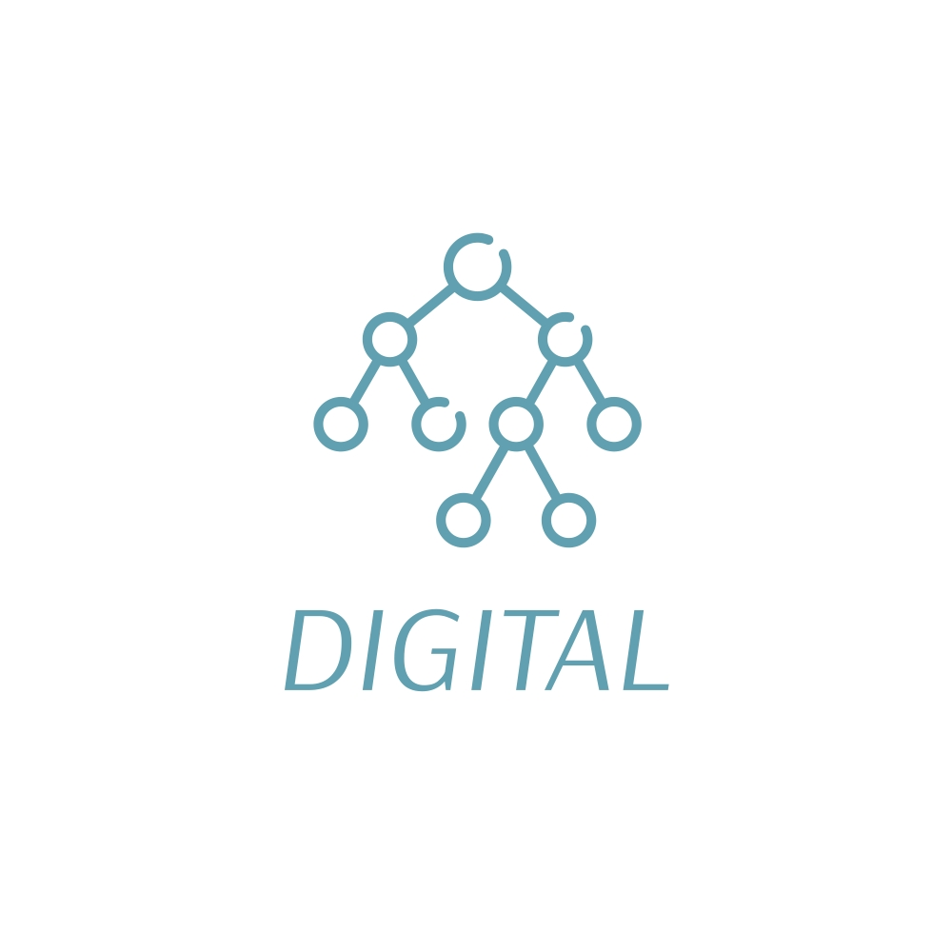
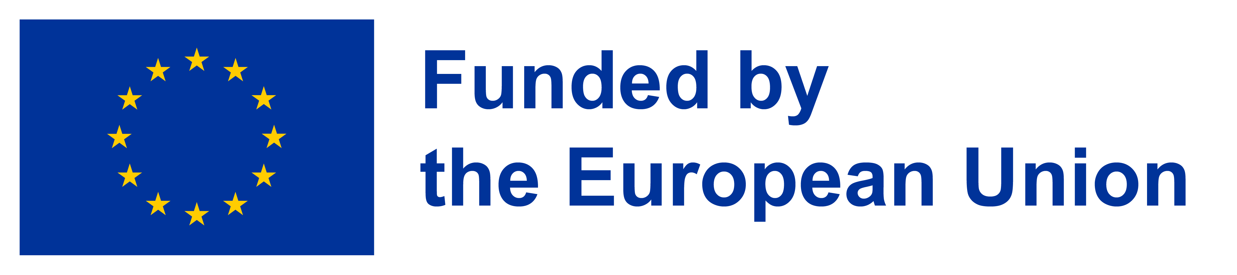




Course Manual Communication Skills / Scientific Communication

Content
Content 2
1. Meet the teaching team 3
2. General course description 3
3. Prior knowledge 3
4. Learning objectives 3
5. Study materials 3
6. Course setup 4
6.1 activity overviews 4
6.2 Assessment 4
6.3 Project due dates 4
6.3 LECTURES AND PRACTICALS FORMAT 4

1. Meet the teaching team
Anne Dijkstra  Associate professor in science communication  Research Centre for Science Communication and Engagement  University of Twente  a.m.dijkstra@utwente.nl | 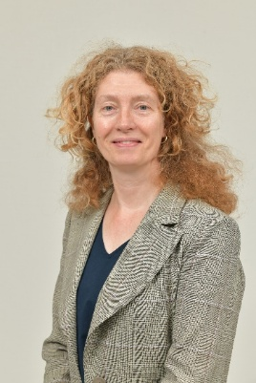
Wendy Tollenaar  Lecturer Communication Skills  University of Twente  w.b.tollenaar@utwente.nl | 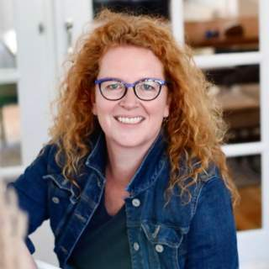
Kees Wesselink-Schram  Science communication officer  University of Twente  k.w.wesselink@utwente.nl | 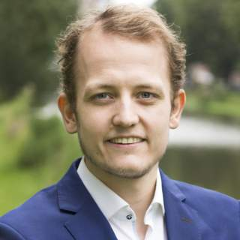

2. General course description
The combined course ‘Communication Skills / Scientific Communication’ (2 ECTS) teaches candidates to communicate effectively about their research with a diverse range of target audiences, while practicing communication skills. Striving for effective communication is a must in today’s society, being it in the workplace to advertise services and products, being it in the academic environment, for example for pitching projects or applying for positions. However, researchers are often not properly trained in communication and therefore can benefit from developing their communication skills and increasing their understanding of science communication. That lack of training is reflected in the media output, in the level of knowledge they assume from the audience and in the way they communicate their achievements.

In this course, candidates will learn to apply principles of communication science to their routine activities, including how to write and speak more effectively for a non-expert audience, and how to tailor communication to the needs of the target audience. Candidates will work on a tailored strategy to communicate their research, taking their communications goals and key stakeholders into consideration.

To achieve the learning objectives, in three workshops of in total 10 hours candidates will be introduced to the basics of communication science within the context of changing roles for researchers in the public domain. With the help of templates, candidates will develop a communication strategy for their research project. They will learn how to find and apply a variety of communication formats that suit various goals and audiences. Candidates will pitch their research with the help of storytelling techniques for a non-specialist audience. Candidates will write a popular article about their research.

Candidates will receive a certificate of completion after completing the course and the assignments.

3. Prior knowledge
No prior knowledge of communication skills or with communicating science is needed for this course. However, the candidates are expected to participate actively and bring in their own experiences and share examples if they have any.

4. Learning objectives
The course addresses 7 learning objectives. By the end of this course, the doctoral candidate will be able to:
- To craft a strong core communication message about the research topic
- To choose a fitting means of communication to the needs of the audience
- To analyse the needs and wishes of your intended audience and translate that into a communication strategy
- To discuss personal approaches for possible communication strategies
- To present the research topic for a non-specialized audience
- To write a popular article about the research topic
- To design a communication strategy for the research project with help of templates

5. Study materials
Course materials will be made available via GitHub.
- Lecture slides and materials provided during the workshops
- Dijkstra, A. M., De Bakker, L., Van Dam, F., & Jensen, E. (2020). Setting the scene. In F. Van Dam, L. De Bakker, A. M. Dijkstra, & E. Jensen (Eds.), Science communication. An introduction (pp. 1-16). World Scientific Publishing Company. https://research.utwente.nl/en/publications/science-communication-an-introduction/
- Dijkstra, A. M., Van Dam, F., & Van der Sanden, M. (2020). The Netherlands: from the first science information officers to the Dutch Research Agenda. In T. Gascoigne, B. Schiele, J. Leach, M. Riedlinger, B. V. Lewenstein, L. Massarani, & P. Broks (Eds.), Communicating Science. A Global Perspective (pp. 597-615). Australian National University Press. https://press-files.anu.edu.au/downloads/press/n6484/pdf/ch25.pdf
- One chapter about the country of work or of the candidate’s origin from the online open access book: Gascoigne, T., Broks, P., Leach, J., Lewenstein, B., Massarani, L., Riedlinger, M., & Schiele, B. (Eds.). (2020). Communicating Science: A Global Perspective. Australian National University Press. https://press.anu.edu.au/publications/communicating-science#tabanchor
Other recommended materials (to be adapted):
- Dijkstra, A. M., de Jong, A., & Boscolo, M. (2024). Quality of science journalism in the age of Artificial Intelligence explored with a mixed methodology. PLOS ONE, 19(6), e0303367. https://doi.org/10.1371/journal.pone.0303367
- Marín-González, E., Navalhas, I., Dijkstra, A. M., De Jong, A., & Luís, C. (2023, 2023-July-14). Science journalism in pandemic times: perspectives on the science-media relationship from COVID-19 researchers in Southern Europe [Original Research]. Frontiers in Communication, 8. https://doi.org/10.3389/fcomm.2023.1231301

- Permanent link to the Github course repository:
https://github.com/MSCA-DN-Digital-Finance/Courses/tree/0a1cbfabfde5ed75e832ee83df4a9048f43f287d/Cohort%201%20(2024.01-2027.12)/MSCA_DF_39

6. Course setup

6.1 activity overviews
The activity overview below is indicative and may be subject to changes.
An indication of the hours, total available 56 hours (2 ECTS):
Estimated time division
- Preparation beforehand: self-study by reading materials and short assignments (16 hours)
- In-person meetings week 9 – 13 June with lectures and interactive activities (10 hours)
- Homework in week 9 – 13 June with preparation for the final meeting, assignments (10 hours)
- Assignments to completion (20 hours), includes an optional consultation or feedback session before submitting the assignment (max 0.5 hour per person)

Date | Time | Instruction mode | Topic | Teacher(s)
 | Beforehand | Self-study and assignment | Reading materials and preparation of short elevator pitch (video of 1 minute) about your research for a non-expert audience.  Bring an object that symbolizes your relationship with research.
Mon 8 June | 13:00 – 16:30 | Workshop 1 | Introduction; presenting for a non-expert audience; sharing experiences with communicating science; presentation techniques; the message box; basics of communicating science; audiences; learning to structure your popular writing process. | Anne Dijkstra / colleague
 |  | Homework | Message box for your own research topic; recommended reading
Wed | 13:00-16:30 | Workshop 2 | Five-step writing process for writing a popular article (part 1); story telling techniques for presenting a story; templates for strategic communication; science-media relationships; changing roles for researchers | Anne Dijkstra / colleague
 |  | Homework | Fill in templates for a strategic communication plan; prepare a poster and a 3-minute pitch to present your plan for a non-expert audience
Thu | 13:00 – 16:00 | Homework | Self-study
Fri | 13:00 – 16:30 | Workshop 3 | Five-step writing process (part 2); developing a strategic communication plan; pitches with peer feedback; reflection | Anne Dijkstra / colleague
After 2 weeks |  | Assignments | Complete your strategic communication plan for your own research topic;  Write a popular research article using story telling techniques; include details about your audience and message;  Write a 1A4 reflection on your views regarding (changing) roles and responsibilities of researchers in the public domain. | Assessment

6.2 Assessment
Candidates are assessed based on their preparation for the course, their active participation during the course; the pitches for a non-specialized audience and the quality of the popular research article and the communication strategy as well as the reflection. In case of insufficient assignments, a single repair opportunity is provided.

6.3 Project due dates
The due dates for the project are as follows:
Due dates | Assignment | Content
29/06/2026 | - Popular research article | Communicating science to a non-expert audience
29/06/2026 | - Strategic research plan | Communicating science utilizing communication skills
29/06/2026 | - Reflection | Communication skills

In case the quality of the assignments is insufficient upon final submission, repair opportunities will be discussed individually.
.3 LECTURES AND PRACTICALS FORMAT
The course will be held in a hybrid setting; although candidates are encouraged to physically attend the communication skills course.
- Workshops
Workshops will be organized in a hybrid setting during the training week on Monday, Wednesday and Friday (total 10 hours). Supplementary guest lectures may be offered online
- Homework
Candidates are expected to work on smaller assignments in between the sessions
- Pitch for a non-expert audience with peer-feedback
The presentation of the research topic for a non-expert audience will preferably be attended in person. Candidates are expected to provide peer-feedback.
- Assignments
The deadline for the assignments is two weeks after the workshops (29/6/2026).

6.4 AI AND GROUP CONTRIBUTION RULES
For all assignments and presentations, it holds that you should hand in/present your own and original work. You must add an “author contribution & use of AI statement” to the group assignment.
The author contribution statement should include who did what (tasks) and what was the relative contribution of each group member to the overall contribution (percentage). Also, all group members should explicitly agree on the final version of the assignment.
Example author contribution statement:
* Name group member 1: Wrote the introduction of the report, produced the mathematical model of Module 1, downloaded and cleaned the data, produced output statistics and wrote answers 1.1 and 2.3. She debugged the Python code to make the mathematical program work. She read the final version of the report and made final edits. [20%]
* Name group member 2: … [30%]
Example of AI statement:
* We declare that no content produced by AI technology has been presented as our own work (both in reporting and coding)
* We declare that we used ChatGPT 4.0 to improve writing at the sentence level and to better express transitions between paragraphs.
* We declare that ChatGPT 4.0 has been used to generate initial code snippets and to generate docstrings for functions.
Note: An extra oral assessment may be part of each assignment as a verification of the authenticity and contribution. Such an oral assessment could also be randomly assigned to a group.

